**Program: Take the size 10 array of any data type assign the value then while printing when you reach the value 5 terminate the loop;**

**Source Code:**

namespace Array4

{

class Program

{

static void Main(string[] args)

{

//Take the size 10 array of any data type assign the value then while printing when you reach the value 5 terminate the loop;

int i;

int[] IntArray = new int[10];

Console.WriteLine("Input 10 numbers");

for (i = 0; i < IntArray.Length; i++)

{

IntArray[i] = Convert.ToInt32(Console.ReadLine());

}

Console.WriteLine("The 5 values are");

for (i = 0; i < IntArray.Length; i++)

{

if (i == 5)

break;

Console.WriteLine(IntArray[i]);

}

}

}

}

**Source in Visual Studio:**

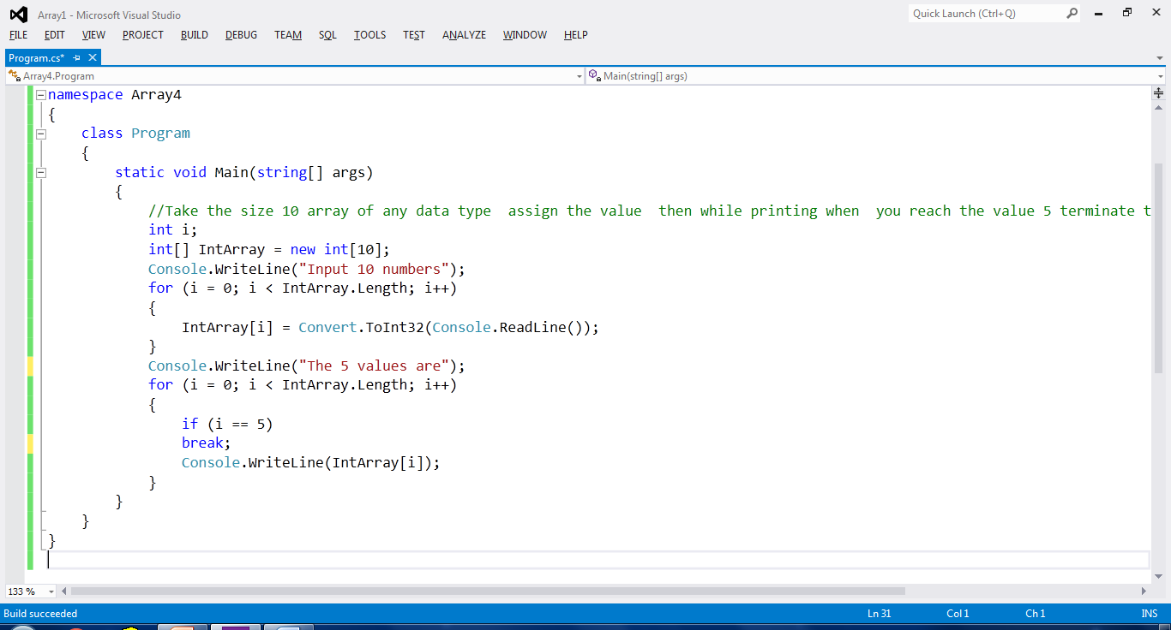

**Output:**

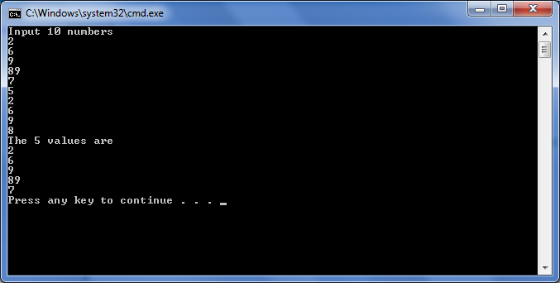

**Program: Take integer type array of size 5 assign the values and print the sum of the array**

**Source Code:**

namespace Array5

{

class Program

{

static void Main(string[] args)

{

//Take integer type array of size 5 assign the values and print the sum of the array

int i,sum=0;

int[] IntArray = new int[5];

Console.WriteLine("Input 5 numbers");

for (i = 0; i < IntArray.Length; i++)

{

IntArray[i] = Convert.ToInt32(Console.ReadLine());

}

for (i = 0; i < IntArray.Length; i++)

{

sum = sum + IntArray[i];

}

Console.WriteLine("The sum is "+sum);

}

}

}

**Source in Visual Studio:**

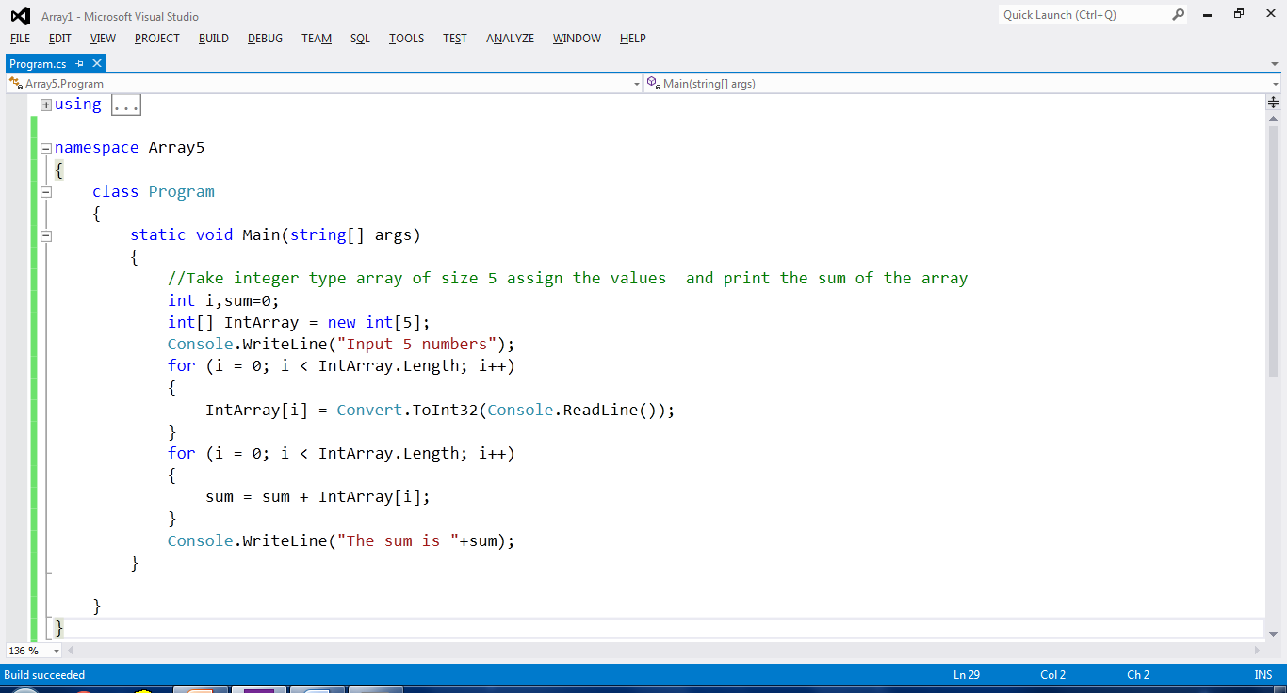

**Output:**

